Needed actions to assess the efficacy and safety of rules for siting of wind turbines
There will certainly be people who live near wind farms who know nothing about the symptoms of Wind Turbine Syndrome (WTS) and Infrasound and Low Frequency Noise Syndrome (ILFNS). http://windsofjustice.org.uk/wp-content/uploads/2014/07/Evans-wind-farms-health.pdf
People who don't think it is worth reporting that they have noticed more headaches, dizziness and not sleeping as well. Also doctors may have misdiagnosed patients as they also are in general, completely unaware of new, existing or even past studies. Vibro Accoustic Disease is also largely unheard of: where internal organs have been damaged by low-frequency noise. Pilots, air stewards and people working on ships and submarines develop a hardening in their internal organs related to the vibration brought on by infrasound. It is now being found that this is happening to people and animals living close to wind turbines. http://windsofjustice.org.uk/2014/08/vibro-acoustic-disease/

To have any chance of governments taking notice, there will have to be a significant amount of people in a community, of varying ages, all developing similar symptoms after a windfarm becomes operational. Due however, to people being unaware of the connection, there is zero recognition of the need to report it.

Needed Actions:

- Carry out a meta-analysis of studies of effects of wind turbine noise (including variation in noise levels) and vibration including information about psychological and physiological effects.

- If further studies are needed the most appropriate approach is to test people’s reactions:
(a) Indirectly e.g. to have them do tasks where replicated noise is brought in to simulate the environment in regions of wind turbines. Those tested are blind to the purpose of the test.
(b) Directly by comparing, on a variety of psychological and physiological measures, those who live near wind farms with a group of age matched controls.

- Define the conditions that define an unsatisfactory noise regime taking account of potential wind conditions, topographical factors, etc.

- Define siting rules that will reduce the risk to a acceptable level of such unsatisfactory conditions occurring. Such level of risk needs to be defined.

- Make the rules mandatory.

- Seek to mitigate the effects for those who are ultra sensitive to noise and vibration e.g. by providing secondary glazing.
Based on studies being done in Australia it is strongly suggested to adopt the AECOM/ DEFRA 1 – 5 rating system for how significant the impact is -as used by Steven Cooper at Cape Bridgewater. This is much better than just “seriously affected/moderately affected/slightly affect/(not affected)” as used in my original survey.The DEFRA one defines the effect for each number of the rating. With the acknowledgement all the AECOM Wind Farm Noise Complaint Methodology (in NANR 277 Defra April 2011) the following severity rankings with respect to noise are set out below:

- No impact (No noise)

- Slight impact (Non intrusive) Noise can be heard, but does not cause any change in behaviour or attitude, e.g. turning up volume of television; speaking more loudly; closing windows. Can slightly effect character of the area but not such that there is a perceived change in the quality of life.

- Moderate Impact (Intrusive) Noise can be heard and causes small changes in behaviour and/or attitude, e.g. turning up volume of television: speaking more loudly; closing windows. Potential for non-awakening sleep disturbance. Affects the character of the area such as there is a perceived change in the quality of life.

- Substantial Impact (Disruptive) Causes a material change in behaviour and/or attitude, e.g. avoiding certain activities during periods of intrusion. Potential for sleep disturbance resulting in difficulty in getting to sleep, premature awakening and difficulty getting back to sleep. Quality of life diminished due to change in character of the area.

- Severe Impact (Physically Harmful) Significant changes in behaviour and/or inability to mitigate effect of noise leading to psychological stress or physiological effects, e.g. regular sleep deprivation/awakening: loss of appetite, significant, medically definable harm, e.g. noise induced hearing loss.
NB In some case residents relate severity 5 to be equivalent to having to leave their premises and go somewhere else because of the noise.
https://www.gov.uk/government/uploads/system/uploads/attachment_data/file/69222/pb-13584-windfarm-noise-statutory-nuisance.pdf page 113

Keeping a diary as recommended by Dr Chris Hanning – sleep specialist:
The simplest diary is to use a linear analogue scale. A horizontal line 10cm long (exactly), one end marked "worse sleep ever", other end marked "best sleep ever" No end bars. So:

Worse sleep ever ________________________________________ Best sleep ever

Subject makes a short vertical mark which corresponds to their assessment of the previous night as soon as they wake in the morning before drawing curtains. Fresh line every morning. Researcher uses a simple ruler to measure distance from left hand end and records the distance (0 = worst sleep) 10 = best sleep)

Researcher should note whether turbines were operating that night.

You could record also any other relevant factors, awakenings, turbines heard, other symptoms etc.

The current ClimateXChange study currently being carried out in Scotland is light on independent members. It is not understood why the survey has not been in the public domain so that it can be judged on quality and transparency. The survey questionnaire apparently included ‘no questions on health related issues or distances those questioned lived from turbines, as it was to compare the difference between the predicted impacts and what we now have in reality. The whole exercise is almost certain to confirm the ‘status quo’ of opinion asserting that "there are no problems" or "there is no reliable evidence".
Professor Colin Hansen's criticism of the NHMRC 2014 literature review mirror that of Dr. Laurie in that goal posts for data inclusion were set so narrow that most of the relevant data was ignored - and that which was included was dismissed.
His critique is found at http://waubrafoundation.org.au/resources/hansen-c-expert-review-nhmrc-draft-information-paper/

This lack of responsible behaviour appears to be breaching a number of UN Conventions on the part of the government regulatory authorities. If it constitutes cruel, inhuman and degrading treatment there could be criminal consequences for the public officials if they KNEW, and did nothing.
It will almost certainly be possible to prove that the complaints of the residents from noise pollution are being deliberately ignored by those responsible despite clear warnings given over some periods of time. The terms of the UN Convention are very clear and are likely to be used. E.g. Having to abandon one's home because the ILFN noise is unbearable http://windsofjustice.org.uk/2014/08/im-abandoning-my-home-over-wind-turbine-illness/ and, having to abandon one's home because of lack of water in winter contamination at other times could be arguably considered cruel, inhuman and degrading treatment. The relevant articles of the convention are articles 1,2 and 4 which can be also be found (for ease of reference) at http://waubrafoundation.org.au/resources/un-convention-against-torture/

There is a need for the public to understand that a frame of reference supporting green energy at all costs does have consequences. They need to be aware of the abuses of human rights which are happening. This is why reminding people that not even a war justifies ‘torture’ - is valid. The oft repeated mantra of "saving the planet" heard in justification - i.e that it is "acceptable collateral damage" because of fighting the good fight on climate change....seems unfortunately, to be a prevalent mentality amongst some in environmental protection. They have forgotten their basic and fundamental duty of care as public servants. Last relevant communication to DECC attached.
http://windsofjustice.org.uk/2014/08/open-letters-to-the-department-of-energy-and-climate-change/

Also reference to water contamination issues raised by Dr Rachel Connor can be viewed at:
http://windsofjustice.org.uk/2014/08/open-letter-to-deputy-chief-medical-officer-re-contaminated-water-supplies/

To enlighten the public at large that not only the health of those living in close proximity is at risk but that the health of the public at large is at risk through the contamination of public and private water supplies. The Scottish Government is proud to support windfarm development in what it considers to be suitable areas. But how can the industrialisation of water catchment areas, once protected by law, be regarded as suitable? The current lack of consideration in allowing and promoting industrialisation of either public or private water catchment areas is contrary to the whole ethos of planning law and flagrantly risks public health and amenity. Whisky Distilleries are dependent on pure water for whisky distillation and need to be concerned about what is happening to their catchment areas.(below are 3 extracts from the video by Dr Rachel Connor:
https://www.youtube.com/watch?v=BQf0hLYXd7o

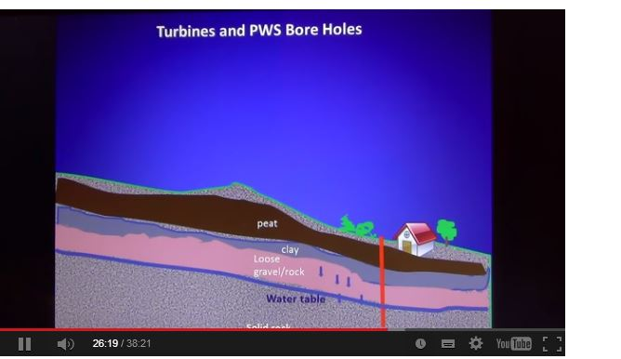
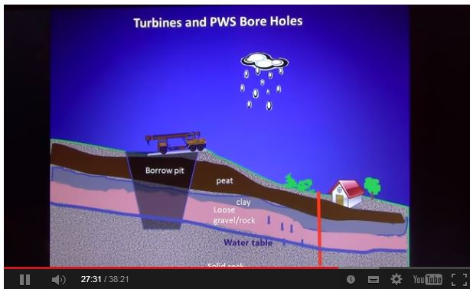

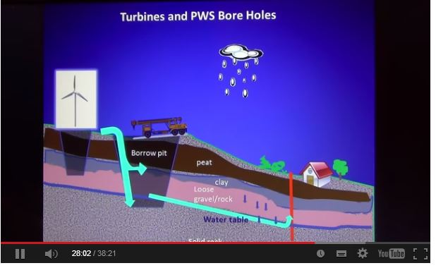

These slides are copied from the video and illustrate how private water supplies and catchment areas are contaminated by the construction of access roads, burrow pits and turbine foundation bases.

